THE ART DEALER GAME

*An Interactive Educational Game for K-8 Students*

**Agile Project Documentation**

**Prepared by:** GROUP: -2

**Prepared for:** Software Engineering Instructor: Dr. Fadi Wedyan **Version:** 1.0

10/18/24

1. Introduction 4
   1. Purpose 4
   2. Scope 5
   3. Overview 6
   4. Document Conventions 7
   5. Intended Audience 8
   6. Project Motivation 8
2. System Overview 9
   1. System Context 9
   2. System Components 9
   3. System Architecture 11
   4. System Dependencies 13
   5. Constraints and Limitations 13
   6. Game Flow 14
3. System Requirements 16
   1. Functional Requirements 16
   2. Non-Functional Requirements 17
   3. Environmental Requirements 19
   4. Constraints and Assumptions 20
4. Functional Requirements 20
   1. User Interactions 21
   2. Game Modes 21
   3. Patterns by Grade Levels 23
5. Gameplay Use Cases 24 Use Case 1: K-2 Grade Level (Single-Player) 24

Use Case 2: Grades 3-5 Level 25

Use Case 3: Grades 6-8 Level (Single-Player) 26

Use Case 4: Grades 6-8 Level (Multiplayer) 27

1. Testing and Ǫuality Assurance 28
   1. Unit Testing 28
   2. Integration Testing 28
   3. User Acceptance Testing (UAT) 29
   4. Load Testing 29
2. Future Enhancements 29
   1. Network Multiplayer 29
   2. Enhanced Graphics 30
   3. Additional Grade Levels 30
   4. Teacher Analytics Dashboard 30
3. Conclusion 30
   1. Final Remarks 30
4. Appendix 31
   1. Installation Guide 31
   2. Screenshots 31
   3. Source Code 31
5. References 32

# 1. Introduction

## Purpose

The **Art Dealer Game** is a comprehensive educational tool designed to engage K-8 students in learning mathematical concepts, computational thinking, and pattern recognition through interactive gameplay. The primary objective of this game is to offer students a fun, gamified environment that supplements traditional learning. This game aims to improve students' understanding of mathematics and critical thinking by encouraging them to recognize patterns, make predictions, and think strategically.

The software is split into three levels corresponding to the grade levels:

* + - **K-2**: Focuses on simple and intuitive pattern recognition such as identifying all cards of the same color or the same suit (e.g., all hearts or all queens).
    - **Grades 3-5**: Introduces more complex patterns such as identifying prime numbers, sums of cards, or a combination of an Ace and a Black Jack.
    - **Grades 6-8**: Builds on the complexity by incorporating patterns based on card values used in poker, such as Full Houses and cards summing to a prime number.

The game's learning goals align with K-8 educational standards in mathematics and computer science, offering teachers and students a flexible, adaptable tool that can be used both in classrooms and at home.

## Scope

The **Art Dealer Game** is an innovative platform that allows students to:

1. **Develop computational thinking**: Students enhance their logical reasoning and problem-solving skills as they engage with different card patterns, attempting to guess what the "art dealer" (either a computer or another player) is interested in.
2. **Strengthen mathematics skills**: Through interaction with card values and patterns (such as prime numbers, sums, and groupings), students reinforce their arithmetic, number theory, and logical reasoning abilities.
3. **Engage with real-world scenarios**: The game models a real-world simulation where students act as gallery owners or art dealers, mimicking buying and selling transactions based on card patterns.
4. **Promote teamwork**: The game offers a multiplayer mode where students can collaborate or compete, encouraging social learning and communication skills.

The game supports both **single-player** and **multiplayer** modes:

* + - **Single-Player Mode**: The student plays against the computer, trying to guess the pattern of cards the computer (acting as the art dealer) is "interested in buying."
    - **Multiplayer Mode**: In this mode, two students play together. One acts as the "art dealer," choosing a card pattern, while the other student attempts to guess it.

The simulation is broken into three levels of complexity:

* + - **Level 1 (K-2)**: Students start with very simple patterns, such as identifying cards of the same color (all red, all black) or the same rank (all queens).
    - **Level 2 (Grades 3-5)**: As students advance, they encounter more sophisticated patterns like prime numbers or sets of cards that add up to specific values (e.g., 9).
    - **Level 3 (Grades 6-8)**: For older students, the game introduces poker-like combinations such as Full Houses and patterns where cards sum up to a prime number. This level requires strategic thinking and a solid understanding of arithmetic and number theory.

## Overview

This document serves as a comprehensive guide to the **Art Dealer Game** project. It outlines the following sections:

* + - **Functional Requirements**: Describes the specific actions and features the system must have to meet the users' needs, including gameplay mechanics, pattern recognition logic, user interface elements, and feedback systems.
    - **Non-Functional Requirements**: Discusses performance benchmarks, security concerns, and usability standards.
    - **System Architecture**: Details the structural design of the game, including its front-end (user interface) and back-end (logic, data handling).
    - **User Interface Design**: Explains the layout, controls, and interactions within the game interface, ensuring ease of use for students and teachers.
    - **UML Diagrams and Flowcharts**: Visual representations of system components, workflows, and interactions between the game's modules, aiding in a clear understanding of its structure.

The game is built with the following features in mind:

* + - **User-Friendly Design**: Designed to be easy enough for young students to interact with, yet robust enough to handle complex computations and patterns.
    - **Extensibility**: The game is built in a way that allows future updates or changes, making it adaptable for additional content or more advanced game modes.
    - **Cross-Platform Compatibility**: The game can be run on different platforms (Windows, macOS, Linux) without requiring complex installation processes.
    - **Feedback and Assessment**: The system provides immediate feedback to students based on their answers, helping them learn through trial and error. Teachers can use the game to track student progress and performance.

## Document Conventions

This document follows standard software engineering conventions to ensure clarity and consistency:

* + - **Bold text**: Used to emphasize important headings and terms.
    - **Italics**: Used for references to other documents or additional materials.
    - **Monospace**: Used for code snippets, file paths, or specific commands.

### Terminology:

* + - **Art Dealer**: The role of the game’s software (or another player in multiplayer mode) that selects a pattern the student must guess.
    - **Cards**: Virtual representations of cards from a 52-card deck, used as learning tools for pattern recognition.
    - **Players**: Refers to students using the game.

## Intended Audience

The **Art Dealer Game** is designed for:

1. **Teachers**: To use as a classroom tool that enhances learning through interactive gameplay. Teachers can guide students through the game's different levels and assess their progress based on how well they recognize patterns and solve mathematical problems.
2. **Students**: To play the game independently or in pairs, learning through engagement and trial and error. Students from grades K-8 can enjoy different levels of complexity based on their learning progress.
3. **Developers and Maintainers**: For future developers or contributors to the project, this document provides the necessary specifications, design principles, and operational guidelines to enhance or maintain the game.

## Project Motivation

In an age where digital literacy is becoming essential, the **Art Dealer Game** provides a platform where learning and fun intersect. The use of virtual cards to teach computational and mathematical thinking not only engages students but also promotes critical thinking, problem- solving, and collaboration skills. The game transforms abstract mathematical concepts into tangible challenges that students can easily understand and apply.

By offering this game in an easy-to-use, flexible format, educators can leverage technology to make complex concepts accessible, while students benefit from an intuitive, enjoyable learning experience.

# System Overview

## System Context

The **Art Dealer Game** is designed to function as an educational tool that runs on multiple platforms, including Windows, macOS, and Linux. It is a standalone software that can be easily downloaded, installed, and executed on any of these platforms without requiring extensive technical knowledge.

The system consists of a user-friendly graphical interface that interacts with users (students and teachers) by displaying cards, accepting user inputs (guesses), and providing immediate feedback based on the correctness of the answers. The system tracks user performance, facilitates multiplayer interaction (where applicable), and adjusts the level of difficulty based on grade levels (K-2, 3-5, 6-8).

## System Components

The system is structured into several components that work together to create the overall experience of the **Art Dealer Game**. These components include:

### User Interface (UI):

* + - 1. The interface is designed to be intuitive, colorful, and engaging, especially for young students. It features clickable buttons, card displays, and user prompts.
      2. The UI adapts based on the grade level selected, offering progressively more challenging patterns and game rules.

### Game Logic:

* + - 1. The core functionality of the game is driven by the game logic, which determines the card patterns the dealer is interested in, processes user inputs, and provides feedback. The game logic varies for different grade levels, allowing the system to challenge students appropriately.
      2. For example, younger students (K-2) will deal with simpler patterns like color- based card groups, while older students (Grades 3-8) will encounter more mathematically complex patterns such as sums, prime numbers, and poker-like combinations.

### Pattern Recognition:

* + - 1. The game features multiple pre-programmed patterns, such as "All Red Cards," "Cards Adding to 9," and "A Full House." These patterns differ based on the selected grade level.
      2. The system recognizes user-selected cards and evaluates them against the pre- defined pattern. If the pattern is matched, the system declares the user as the winner.

### Feedback Mechanism:

* + - 1. The game provides real-time feedback to the player. Upon making an incorrect guess, the system provides clues and hints to help the player understand the logic behind the pattern.
      2. When the player wins, they are congratulated with colorful visual effects such as balloons and flowers, reinforcing a positive learning experience.

### Multiplayer Mode:

* + - 1. In multiplayer mode, one player acts as the "art dealer," selecting a pattern from a list of pre-defined options. The other player acts as the "gallery owner," attempting to guess the pattern based on the displayed cards.
      2. Multiplayer mode fosters collaboration and teamwork, as two students can participate in the game together, learning through interaction and competition.

### User Data and Progress Tracking:

* + - 1. The game tracks each student’s progress by storing their correct and incorrect answers, level achievements, and time spent on each pattern. Teachers can use this data to assess student performance and identify areas where students may need additional support.
      2. The system is capable of generating basic progress reports that can be accessed by teachers to monitor student learning over time.

## System Architecture

The **Art Dealer Game** is built using the Python programming language, leveraging standard libraries for UI design and game logic. The architecture follows a modular approach, making it

easy to maintain, update, or expand the software in the future. Below is a high-level description of the system’s architecture:

### Input Layer:

* + - 1. This layer handles all user interactions, including card selections, pattern guesses, and navigation through the game menu.
      2. It also processes input validation, ensuring that only valid card combinations and patterns are selected.

### Processing Layer:

* + - 1. The processing layer runs the game logic, which includes evaluating card selections against pre-defined patterns, determining correct guesses, and adjusting game difficulty based on the user’s grade level.
      2. It also manages the multiplayer logic, where one player selects a pattern and the other tries to guess it.

### Output Layer:

* + - 1. This layer is responsible for displaying the game’s output, such as the card deck, user prompts, and feedback (e.g., correct guess, wrong guess).
      2. It also triggers celebratory animations when the player wins and displays sad emojis when the player loses.

### Data Storage:

* + - 1. The system temporarily stores user selections and game progress in memory during each session. This data is cleared at the end of each session, ensuring that no personal data is stored persistently.

## System Dependencies

The following dependencies are required to run the **Art Dealer Game**:

* **Python 3.6 or later**: The game is written in Python, and users will need a version of Python 3.6 or later installed on their systems to run it.
* **Standard Python Libraries**: The game relies on several built-in Python libraries for handling user inputs, running game logic, and generating random card selections. These libraries are available by default in Python distributions.
* **Cross-Platform Compatibility**: The game is designed to run on Windows, macOS, and Linux operating systems. The installation process is straightforward and does not require any additional software beyond Python.

## Constraints and Limitations

* **Limited Graphics**: The game uses basic text-based user interface components and does not include high-end graphical representations of cards. This decision was made to prioritize accessibility and cross-platform compatibility over visual fidelity.
* **No Persistent Storage**: While the game tracks user progress during a session, it does not store data permanently. If the game is closed, all progress is lost. Future versions may introduce saving and loading functionality to allow students to resume their sessions.
* **Multiplayer Only on the Same Device**: The multiplayer mode is currently limited to two players using the same device. Future expansions could include networked multiplayer options, allowing students to play against each other remotely.

## Game Flow

The **Art Dealer Game** follows a structured process based on the grade level chosen by the player. The game proceeds with the following steps:

* + 1. **Start**: The game begins, and the player is presented with options to select a grade level.

### Grade Level Selection:

* + - 1. The player chooses from three grade levels: **K-2**, **Grades 3-5**, or **Grades 6-8**.

### Card Selection and Guessing:

* + - 1. The player is presented with a set of cards to select from.
      2. Based on the selected grade level, the player must identify the pattern or meet the card combination criteria defined for that level.

### Win or Lose:

* + - 1. After guessing the pattern or selecting the cards, the system checks if the player's guess or card selection is correct.
      2. The player either wins (correct selection) or loses (incorrect selection) and receives feedback.
    1. **End**: The game either ends or offers the player a chance to restart and play again.

Below is the flowchart that illustrates the game flow:

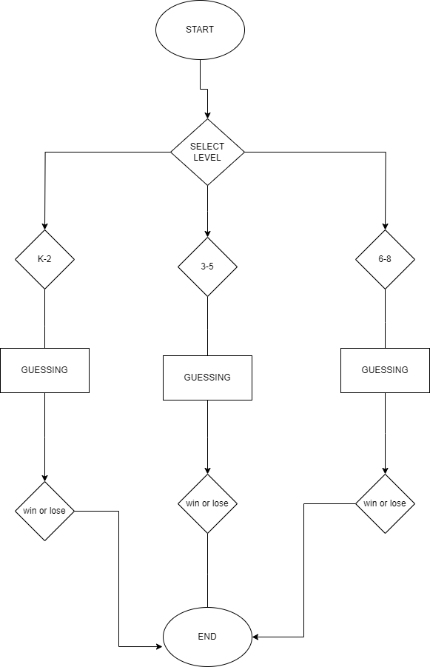

Fig 2.1:-The Art Dealer Game Flow Chart

# System Requirements

This section outlines the key requirements for developing and running the Art Dealer Game, including the functional, non-functional, and environmental needs for optimal performance.

## Functional Requirements

Functional requirements describe the key features and functionalities that the system must support to ensure successful gameplay. They include user interactions, gameplay mechanics, and the system's response to inputs.

### Grade Level Selection:

* + - 1. The system should allow the player to choose the appropriate grade level (K-2, Grades 3-5, Grades 6-8).
      2. The game content should adjust based on the selected grade level to match the difficulty level with the player's abilities.

### Game Mode Selection:

* + - 1. The player should be able to choose between **Single-Player** and **Multiplayer**

modes.

* + - 1. In **Single-Player Mode**, the system acts as the "art dealer."
      2. In **Multiplayer Mode**, one player selects the pattern (dealer), and the other player tries to guess it.

### Pattern Selection (Multiplayer Mode):

* + - 1. The player acting as the "art dealer" should be able to choose a card pattern from a list (e.g., Prime Numbers, Full House, etc.).

### Card Selection and Guessing:

* + - 1. The system should allow the guessing player to select cards in each round.
      2. The player should be able to choose from a pool of randomly generated cards.
      3. In multiplayer mode, the cards should be laid out by the "art dealer."

### Feedback on Guesses:

* + - 1. The system must provide immediate feedback after each guess.
      2. If the player's guess is correct, celebratory messages (e.g., balloons, flowers) should be displayed.
      3. If the player's guess is incorrect, the system should display sad emojis and explain why the guess was wrong.

### Restart Option:

* + - 1. After each game round, the system should ask if the player wants to play again, providing a seamless way to restart the game.
      2. In case of "yes," the game should reset to the initial grade selection.

### Multiplayer Turn Management:

* + - 1. In multiplayer mode, the system should alternate between Player 1 (art dealer) and Player 2 (guesser).
      2. The game should ensure that both players have completed their roles before providing the result of the round.

## Non-Functional Requirements

Non-functional requirements focus on the quality attributes of the system, such as usability, performance, reliability, and scalability.

### Usability:

* + - 1. The game interface should be intuitive and easy to use, especially for younger students (K-2 level).
      2. The game should provide clear instructions, feedback, and visual cues that guide players through the game mechanics.

### Performance:

* + - 1. The game should run smoothly on all supported platforms, with minimal load time.
      2. Gameplay interactions (such as card selections and pattern checking) should be processed quickly, with feedback provided within 1-2 seconds.

### Cross-Platform Compatibility:

* + - 1. The game should be compatible with multiple platforms, including Windows, macOS, and Linux.
      2. Installation should be simple, with a downloadable file that can be run on any platform without additional setup requirements (e.g., complex installations or manual configuration).

### Error Handling:

* + - 1. The system should handle invalid inputs gracefully (e.g., invalid card selection, invalid input format).
      2. If an error occurs, the game should notify the user with a clear message and allow them to retry without losing progress.

### Security:

* + - 1. Multiplayer sessions should not share personal data between users.
      2. The game does not need to store sensitive information, and no external network connections are required during gameplay.

## Environmental Requirements

### Hardware Requirements:

* + - 1. **Processor**: A 2 GHz dual-core processor or higher.
      2. **RAM**: At least 2 GB of RAM is recommended for optimal performance.
      3. **Storage**: Minimum of 100 MB of free storage space to download and install the game.
      4. **Graphics**: The game uses a simple text-based interface, so no specialized graphics card is required.

### Software Requirements:

* + - 1. **Operating Systems**: Windows (7 or later), macOS (10.11 or later), Linux (any modern distribution).
      2. **Python**: The game is built in Python and requires Python 3.6 or later to run. Users should have Python pre-installed or should install it following the provided instructions.
      3. **Libraries**: The game uses standard Python libraries (e.g., random, sys, os), which are pre-installed with Python.

### Development Environment:

* + - 1. The game is developed using Python 3.x and can be modified using any Python- supported Integrated Development Environment (IDE), such as PyCharm, VS Code, or Jupyter Notebook.
      2. The source code is available on GitHub for developers who wish to maintain or modify the game.

## Constraints and Assumptions

### Assumptions:

* + - 1. Users will have basic reading and typing skills to interact with the game (especially for younger users in K-2).
      2. The game will primarily be used in educational settings, with a teacher guiding students through gameplay.

### Constraints:

* + - 1. The game uses a text-based interface, which limits its graphical richness. Future versions could implement a more visually interactive design.
      2. No persistent data storage is implemented, so students cannot save and resume their sessions across different days.

# Functional Requirements

This section outlines the primary functionalities that the Art Dealer Game must provide to meet the needs of users, including both students and teachers. Each functional requirement describes specific interactions, game modes, and patterns according to the educational level of the player.

## User Interactions

The game allows users (students) to interact with a virtual "art dealer" by selecting patterns from a deck of cards. The interactions vary depending on the grade level of the player. For each round, users are prompted to guess patterns or make card selections.

Key interactions include:

* + - **Grade Level Selection:** Players select their grade level (K-2, 3-5, or 6-8) at the beginning of the game.
    - **Single-Player Mode:** Players guess patterns against the computer (art dealer).
    - **Multiplayer Mode:** Two students can compete where one student acts as the art dealer and the other guesses the pattern.
    - **Card Selection:** Players are presented with a deck of cards and can select one or multiple cards depending on the game mode.
    - **Feedback System:** Based on their selection, students are informed if their guess was correct or incorrect. If they win, they are rewarded with positive feedback (balloons, flowers); if incorrect, they receive clues or sad emojis to help them understand the logic.

## Game Modes

The game offers two main modes:

* + - **Single-Player Mode:** The player competes against the system, which acts as the art dealer. The player guesses which pattern the system has selected based on the displayed cards. This mode is suitable for self-learning.
    - **Multiplayer Mode:** Two students can play together. One acts as the art dealer, selecting a pattern from a list of pre-defined patterns, while the other player tries to guess it. This encourages collaborative learning and critical thinking.

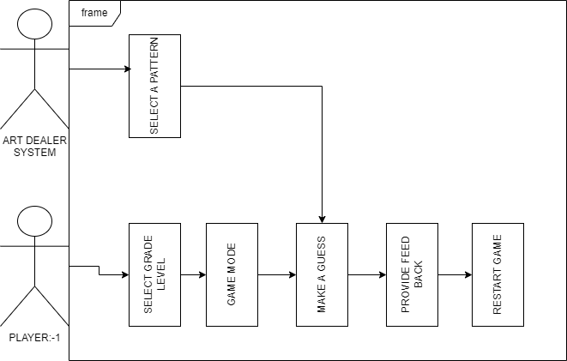

## Patterns by Grade Levels

The game has three levels, each with a different level of complexity in the patterns. These levels are aligned with the students' grade levels.

* + - **K-2 (Easy):** The simplest patterns include guessing if all cards are of the same color (e.g., all red) or the same type (e.g., all Queens). This helps students practice color and type recognition.
    - **Grades 3-5 (Medium):** This level introduces more complex patterns such as:
      * **All Prime Numbers:** The student must identify cards that represent prime numbers (e.g., 2, 3, 5, 7).
      * **Cards Adding to 9:** The student must select cards that total to 9.
      * **Ace and Black Jack:** Students must recognize the combination of an Ace and a Black Jack (Jack of spades or clubs).
    - **Grades 6-8 (Hard):** This level adds poker-style patterns, including:
      * **A Full House:** A combination of three cards of one rank and two cards of another rank (e.g., 3 Kings and 2 Aces).
      * **All Cards Are Spades:** Students must select cards that all belong to the spades suit.
      * **Cards Adding to a Prime Number:** The cards’ values must add up to a prime number (e.g., 7, 11, 13).

# Gameplay Use Cases

This section outlines different gameplay scenarios as use cases, demonstrating how the game works across various grade levels and modes. Screenshots will be provided to help visualize the user experience.

## Use Case 1: K-2 Grade Level (Single-Player)

**Objective:** Player attempts to guess simple patterns such as all cards being the same color or all being queens.

1. **Actor:** Player (Student)
2. **Precondition:** The player has selected grade level **K-2**.

### Main Flow:

* 1. Player selects **K-2** from the grade level selection.
  2. The system displays a set of cards, and the player is asked to guess a pattern from options like "All Red Cards," "All Black Cards," "All Queens."
  3. The player guesses three times, receiving feedback after each guess.

1. **Postcondition:** If the guess is correct, a celebration with balloons and flowers is shown.

If incorrect, sad emojis appear.

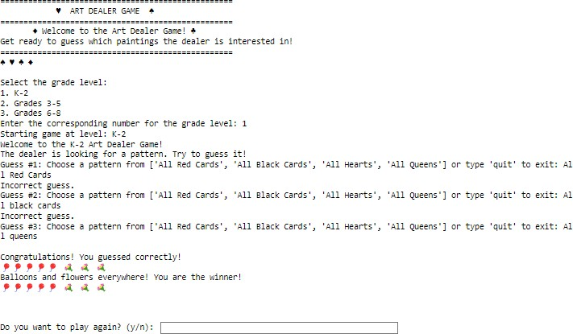

## Use Case 2: Grades 3-5 Level

**Objective:** Player guesses more complex patterns like prime numbers or sums of cards.

1. **Actor:** Player (Student)
2. **Precondition:** The player has selected grade level **Grades 3-5**.

### Main Flow:

* 1. Player selects **Grades 3-5** from the grade level selection.
  2. The system generates a random set of cards and asks the player to guess the pattern.
  3. Patterns could include "All Prime Numbers" or "Cards Adding to 9."
  4. Player selects cards one at a time and submits their guess.

1. **Postcondition:** The system checks if the pattern is correct. If so, celebration icons are shown; otherwise, sad emojis are displayed, and a learning clue is provided.

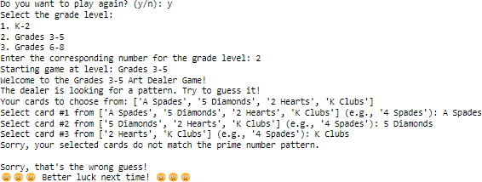

## Use Case 3: Grades 6-8 Level (Single-Player)

**Objective:** Player guesses more advanced patterns, such as poker-style combinations.

1. **Actor:** Player (Student)
2. **Precondition:** The player has selected grade level **Grades 6-8**.

### Main Flow:

* 1. Player selects **Grades 6-8** from the grade level selection.
  2. The system displays a set of cards, and the player is asked to guess a pattern like "Full House" or "Cards Adding to a Prime Number."
  3. Player selects cards from the set and guesses the pattern.

1. **Postcondition:** The system checks the guess. If correct, the player is shown balloons and flowers. If wrong, the system displays sad emojis and clues.

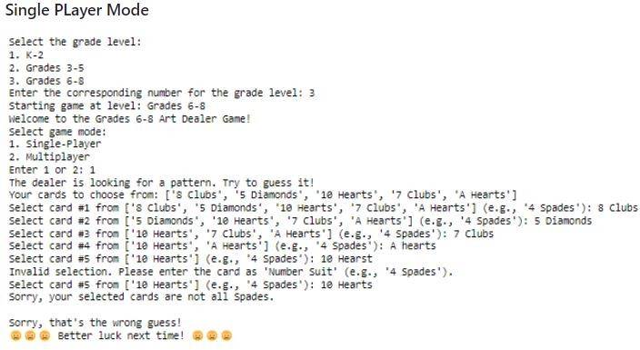

## Use Case 4: Grades 6-8 Level (Multiplayer)

**Objective:** Two players interact, one choosing a pattern and the other guessing it.

1. **Actor:** Player 1 (Art Dealer), Player 2 (Gallery Owner)
2. **Precondition:** The players have selected grade level **Grades 6-8** and **Multiplayer** mode.

### Main Flow:

* 1. Player 1 selects a pattern from a list (e.g., "Full House," "All Cards Are Spades").
  2. Player 2 selects cards from the set provided by Player 1, attempting to guess the pattern.

1. **Postcondition:** The system checks the guess and provides feedback. If correct, balloons and flowers are shown. If incorrect, sad emojis appear.

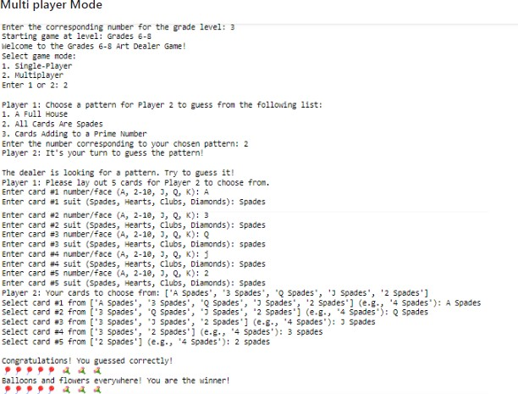

# Testing and Quality Assurance

This section outlines the different testing strategies employed to ensure that the Art Dealer Game is bug-free, meets performance standards, and adheres to the requirements outlined in earlier sections.

## Unit Testing

* + - **Purpose**: Unit tests were created for individual functions within the game. These tests ensure that each component works in isolation without errors.

### Examples:

* + - * Tests were written to verify the pattern matching logic for each grade level.
      * For instance, the logic for identifying a "Full House" or detecting prime numbers in card values was tested to ensure accuracy.
      * Feedback mechanisms for correct or incorrect guesses were also tested.

## Integration Testing

* + - **Purpose**: Integration testing ensured that all game components—game logic, user interface, and multiplayer functionality—work together seamlessly.

### Examples:

* + - * Integration tests were conducted to verify that the card generation system correctly communicates with the pattern recognition engine.
      * Tests ensured that player selections (guesses) correctly triggered the feedback mechanisms (win/loss).

## User Acceptance Testing (UAT)

* + - **Purpose**: To validate the system with real users (teachers and students) and ensure it meets educational and usability requirements.

### Methods:

* + - * The game was tested in both single-player and multiplayer modes with K-8 students to confirm its usability, engagement factor, and alignment with educational goals.
      * Feedback from teachers was gathered to ensure the game could be used effectively in classroom environments.

## Load Testing

* + - **Purpose**: Load testing was conducted to assess the game's performance under heavy usage conditions.
    - **Outcome**: The game demonstrated the ability to handle multiple rounds of gameplay, including multiplayer sessions, without any degradation in performance.
      * No significant delays were observed during card selections or feedback generation.

# Future Enhancements

This section outlines several possible enhancements that can be made in future versions of the Art Dealer Game to improve its educational value and engagement.

## Network Multiplayer

* + - **Feature**: The current version supports multiplayer on a single device. Future enhancements could introduce a networked multiplayer mode that allows students to play against each other from different devices or locations.
    - **Benefit**: This would enable teachers to use the game for remote learning or allow students to play in different classrooms while still interacting with each other in real-time.

## Enhanced Graphics

* + - **Feature**: Adding more advanced graphics, including animations for cards and interactive sound effects.
    - **Benefit**: These improvements would enhance student engagement and make the game feel more interactive and fun.

## Additional Grade Levels

* + - **Feature**: The current game is tailored for K-8 students. Future updates could include additional grade levels or specialized topics such as fractions, geometry, or more complex algebraic concepts.
    - **Benefit**: This would expand the game's use across a wider range of educational topics, making it a more versatile learning tool.

## Teacher Analytics Dashboard

* + - **Feature**: Develop an admin portal that allows teachers to monitor student progress, review game performance, and identify areas where students struggle.
    - **Benefit**: Teachers would have access to data that could help in assessing individual student performance, track learning outcomes, and identify areas requiring additional support.

# Conclusion

The Art Dealer Game serves as an innovative platform that enhances both individual and classroom learning experiences. By combining core mathematical concepts with engaging gameplay, the game encourages K-8 students to develop critical thinking and problem- solving skills.

## Final Remarks

* + - The game's interactive and adaptive design ensures that students across all learning levels can participate in meaningful, educational gameplay. Whether in single-player mode, where students challenge themselves, or in multiplayer mode, where teamwork and collaboration are key, the Art Dealer Game bridges the gap between learning and fun.
    - Moving forward, the potential for additional features such as networked multiplayer modes, enhanced graphics, and expanded grade levels opens up opportunities to make the game even more impactful in educational settings.

# Appendix

This section contains additional resources, references, and technical details for users and developers.

## Installation Guide

### Windows/Mac/Linux:

* + - * Visit the GitHub repository for the Art Dealer Game.
      * Download the project zip file.
      * Unzip the file in your preferred directory.
      * Open a terminal or command prompt.
      * Navigate to the project directory.
      * Ensure you have Python 3.6 or later installed.
      * Run the game using the command python final.py.

## Screenshots

Include relevant screenshots showing gameplay for each grade level:

* + - **K-2 (Single Player)**: Screenshot showing simple pattern selection, such as "All Red Cards."
    - **Grades 3-5 (Single Player)**: Screenshot showing prime number pattern selection.
    - **Grades 6-8 (Single Player)**: Screenshot displaying the "Full House" pattern.
    - **Grades 6-8 (Multiplayer)**: Screenshot showing the interaction between two players in multiplayer mode.

## Source Code

The source code for the Art Dealer Game can be found at:

* **GitHub Repository**: [https://github.com/AjayGopavarapu/THE-ART-DEALER-](http://repository/)

[GAME.git](http://repository/)

* Developers can contribute by forking the project or submitting pull requests.

# References

Include any references used in the development or research for the Art Dealer Game:

* **Pressman, R. S. (2020).** *Software Engineering: A Practitioner’s Approach* (9th Edition). McGraw-Hill Education.
* **Educational Standards**: Align the gameplay with K-8 mathematical standards for pattern recognition and computational thinking.